CS 255 System Design Document Template

UML Diagrams

UML Use Case Diagram
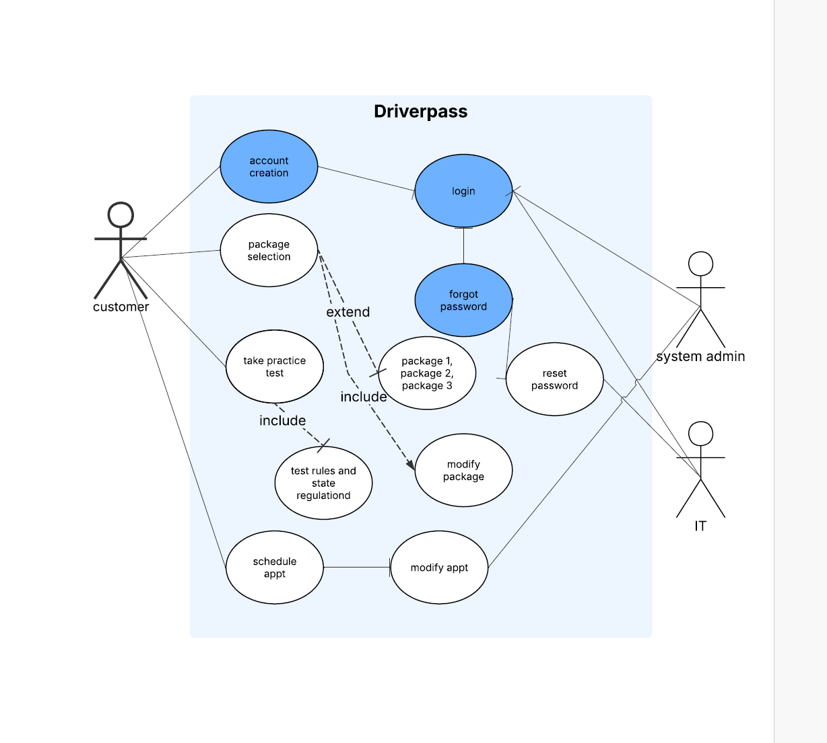

UML Activity Diagrams
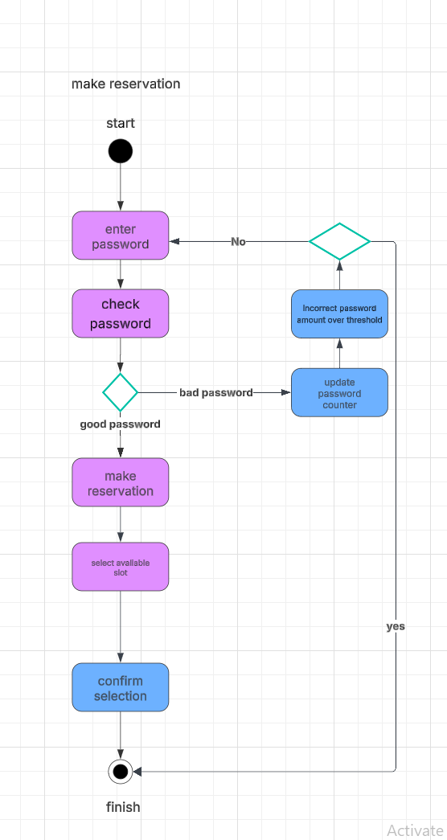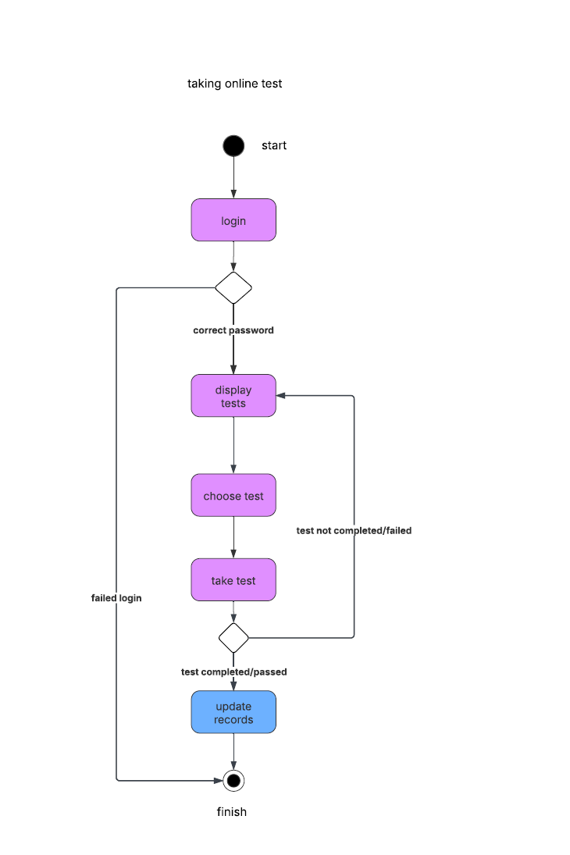

UML Sequence Diagram
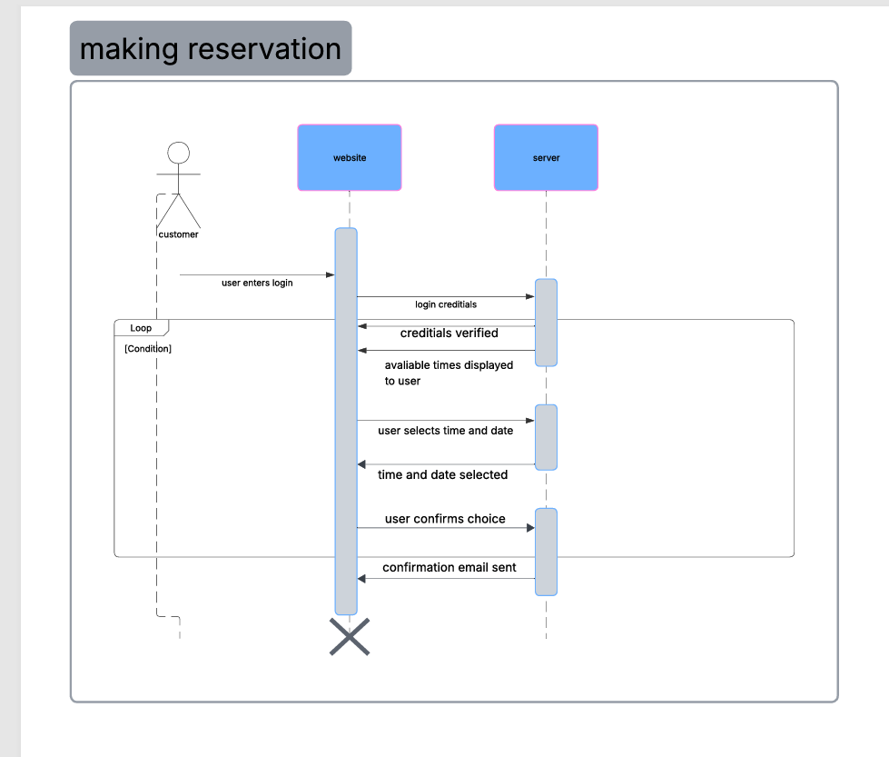

UML Class Diagram
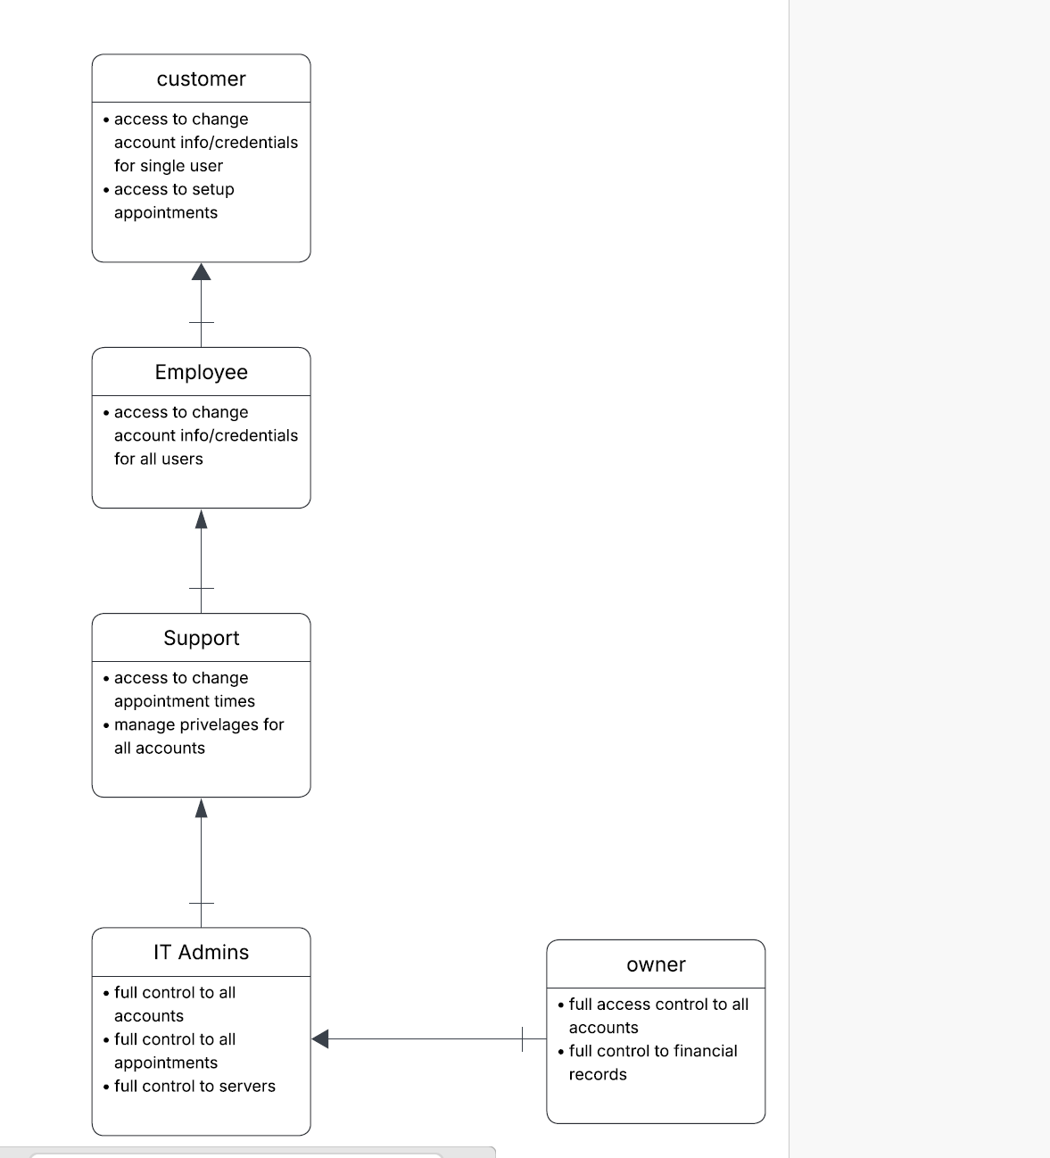

Technical Requirements
- Servers equipped with high-performance processors
- Users accessing the system via modern computers or mobile devices with reliable internet connections
- Server software running on Windows platforms
- Comprehensive tools available for building, testing, and maintaining the application
- Security protocols such as firewalls and data encryption in place
- Design that is intuitive, user-friendly, and responsive across all device types
- Accessibility options included to support individuals with disabilities
- Capability to accommodate a large number of simultaneous users
- Utilization of cloud services like AWS

